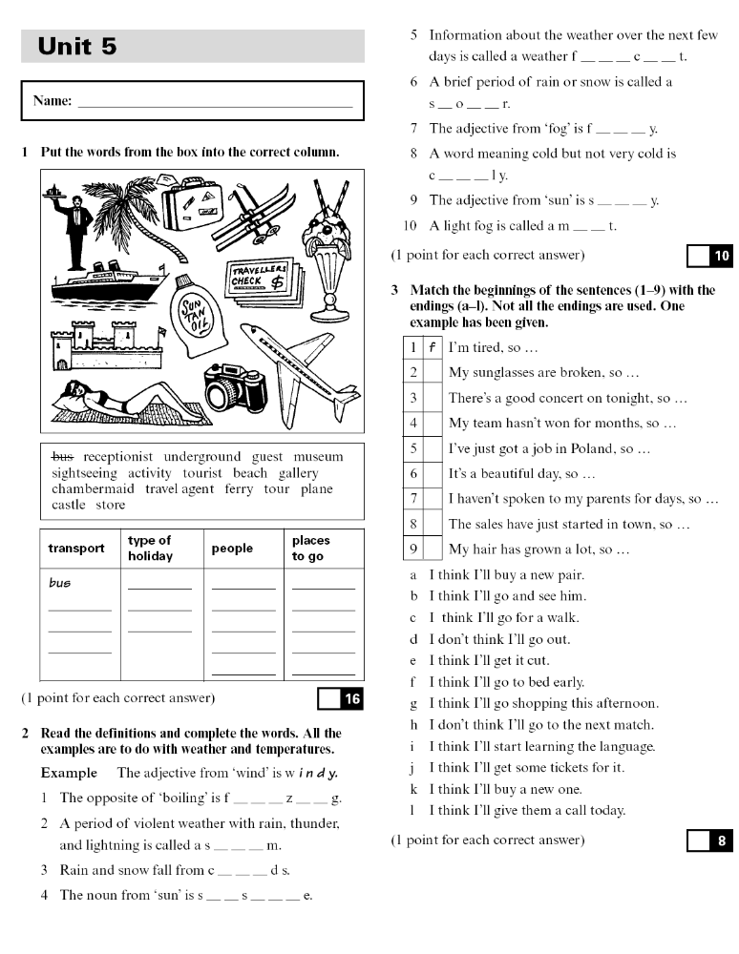

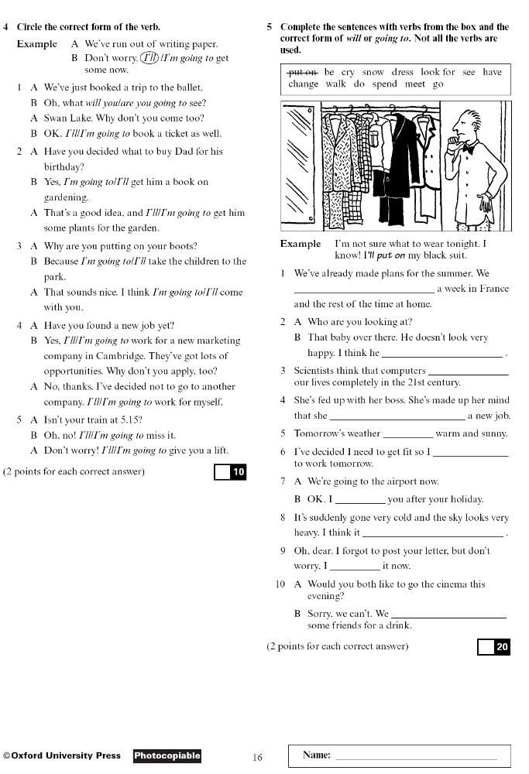

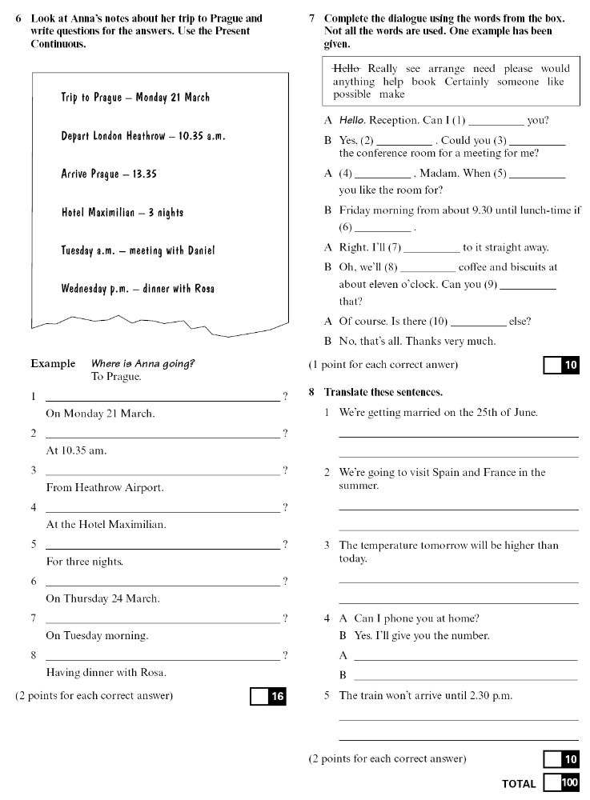

Fill in the gaps using will, be going to or the Present Continuous Tense
- My cousins _________________ (come) to dinner tomorrow.

2. She has bought a lot of food this morning. She ______________
(prepare) a delicious lunch today.

- She has studied a lot. She __________________ (pass) an exam.

- A: “Where are you going tomorrow?”
B: “I ______________ (travel) to the seaside.

- Why are you taking that big basket? I ___________________ (buy) a lot of vegetables.

6. There’s somebody on the door! Ok, I ___________________ (go) and
check who it is.

- My father _________________ (take) my mother to a fancy restaurant tonight. They ___________________ (celebrate) their wedding anniversary.

8. Oh, no! I forgot to post this letter. Don’t worry. I
_______________(post) it for you on my way home.

- I think that you can’t do it by yourself. I _____________ (help) you
finish it.

- Look at that tree! It __________________ (fall) down.

11. I don’t think he ____________________ (manage) to do it today.

- She looks wonderful. She _____________ (have) dinner with her boyfriend tonight.

- I didn’t know that you had spent all your money. I ______________ (lend) you some tomorrow.

- We __________________ (have) party next Saturday.

15. “Why are you putting your old clothes on?”
“Because I __________________ (cut) the grass.

- I __________________ (have) lunch with the president today.

- She is waiting for him to call her. I don’t think he _________________ (call) her.

- “He has just been taken to hospital with a broken leg.”
“I’m sorry to hear that. I ______________ (send) him some grapes.

- “Why do you have so much food?”
“Because I ____________________ (cook) a meal for ten people.”

- “I passed my driving test!”
“That’s great! I _________________ (buy) some champagne to celebrate!”

- I ____________________ (have) dinner with my business
partners tonight.”

- “Oh, dear. I’m late for work.”
“Don’t worry. I _________________ (give) you a lift.

- Look at her sad face! She ___________________ (cry).

24. “It’s Tony’s birthday next week.”
“Is it? I didn’t know. I __________________ (send) him a card.

25. I ____________________ (go) out with my friends next week.



